Утверждаю
14.11. 2025 года
Протокол метод совещания кафедры №15
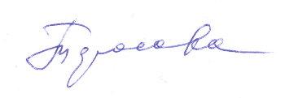

The procedure for conducting intermediate certification at the Department of Otorhinolaryngology in the discipline of Otorhinolaryngology for students 2022-2023 years of admission to the specialty 05/31/03 DENTISTRY, focus DENTISTRY in the fall semester 2025-2026 full-time education

1. Intermediate certification in the specialty of Otorhinolaryngology is carried out strictly on the date and time set by the approved schedule (schedule of tests)
2. Intermediate certification at the Department of Otorhinolaryngology in the discipline of Otorhinolaryngology for students of the specialty Pediatrics is conducted in the form of a test.
3. The student is allowed to intermediate certification on condition of full assimilation of the material of the cycle on otorhinolaryngology and if he has access to intermediate certification.
4. The interim assessment is conducted in the form of an interview on control issues according to the selected ticket. The ticket contains three questions on different sections of otorhinolaryngology provided for the study of the educational program in the discipline of Otorhinolaryngology. The answer to the question is provided orally if the intermediate certification is conducted in person, or in the form of a written answer if the DOT is applied.
5. Preparation for the answer takes 15-30 minutes. The answer is evaluated by the teacher during the test and announced to the student.
6. When assessing knowledge, the teacher takes into account the rating score for the semester. The assessment and basic information on the ticket are entered in the score sheet, which is signed by the teacher.
7. Upon receipt of the statements, the head of the department checks them, prints them out, approves them, then either scans the signed statements and sends scanned copies to the e-mail of the relevant dean's office on the same day, or transmits the completed statements on paper personally.
8. Deans/heads of training areas approve printed scanned copies of the statements or their originals; based on them, grades are placed by the dean's office staff in the credit books (in full-time PA format, grades from the statements are checked with grades entered in the credit books) and other documents accounting for the student's academic achievements (individual curricula, etc.) signed by the dean/head of the training area
Head of the Department of Otorhinolaryngology 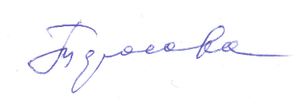 Тарасова НВ

